# User Guide

## Introduction

Project Portal is a project collaboration web application. The system was designed with tools to allow project teams to communicate project information. Team members can share a calendar, a map, and project-related files. Because Project Portal was created with ease of use in mind, the application can be viewed from any of the primary web browsers: Explorer, Chrome, Firefox, etc.

🞸**Note -** All references in this chapter to server names have been changed to “server”. The reason for this change is due to security concerns by DNR.

## Logging On

To enter Project Portal, open your favorite web browser. In the address bar, enter http://server/projectportal. Then hit enter. On the landing page, click the “Login” button. On the login page, enter your LDAP user name and password. If you don’t already have a username and password, you will have to contact your department’s IT professionals or your manager to get them. Click the “Log in” button. Choose what page to navigate to from the navigation bar/tabs on the top of the page.

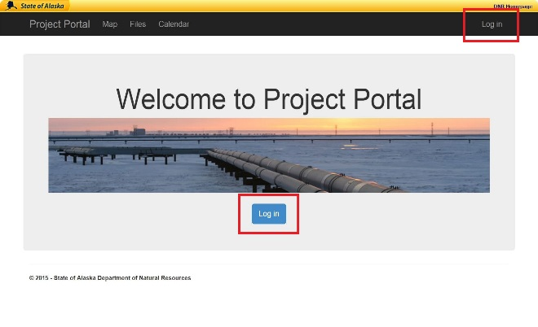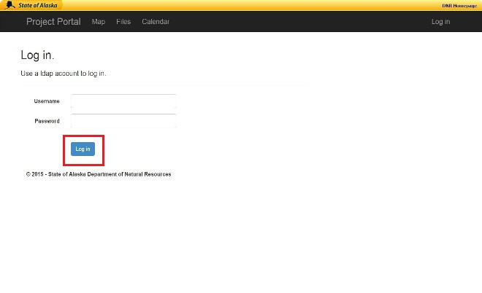

Figure . – Log in button locations for the landing and login pages.

## Using the Map

Once logged in, click on the map tab in the navigation bar.  Wait briefly for the page to load – you should see a map with a legend on the left-hand side. To use the features of the map, see each subheading below.

### Zoom

To zoom in, click on the plus button  on the map. Likewise, to zoom out, click on the minus button  on the map.

### Scroll and Pan

To scroll and pan, left click and hold the mouse button and then move your mouse the direction you wish to move the map.

### Changing Map Layers

If you need to change the map layers, click the check box  within the legend related to the layer you wish to activate or deactivate. As many layers as desired can be selected; however, the more layers that are selected, the slower the map will load.

## File Browser

First make sure you are logged in. Click on the “Files” tab in the navigation bar.  The file browser will now be visible

### Navigating Through Folders

To navigate back to a previous folder click on the folder in the folder tree or click on the “Back” button.  To navigate forward to a previous folder, click on the folder in the folder tree or click on the “Forward” button.  You can navigate to any folder by simply clicking on the folder in the folder tree. The file path is displayed just above the folder view for addition location information.

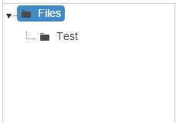

Figure . – Folder Tree View

### Refreshing the Browser view

To refresh the view of the browser, click on the refresh button. 

### Changing the Browser View

For a thumbnail view, click the thumbnail button. 

For the list view, click the grid icon. 

### Deleting a File

To delete a file, click the delete button or right-click on the file and select the “Delete” option.

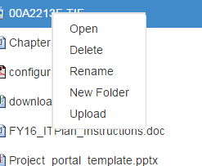

Figure . – Right click options menu

### Uploading a File

To upload a file to the server, click on the “Upload” button  or right click in the browser window and select the “Upload” option from the menu.

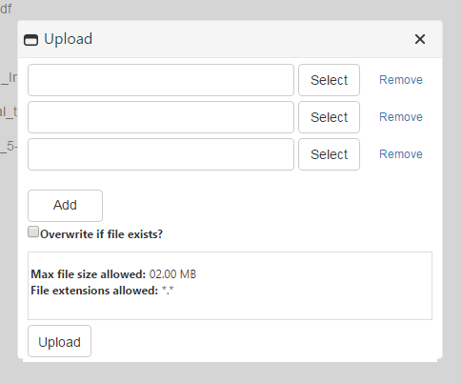

Figure . – Upload pop-up

After the pop-up is visible, click the top “Select” button  and choose a file to upload. If uploading more than one file, continue to use the “Select” buttons  in descending order and choose the other files you wish to upload. If you need to upload more than three files, click the “Add” button.  If you need to remove a file you’ve selected, click the “Remove” button  associated with the file you selected. There is an option to overwrite files if they exist. If you wish to overwrite the files, click the box next to the question. Currently, the maximum single file size allowed for uploading is 2MB. If you need to upload a file greater than that maximum, you will need to contact the application administrator. All file types are allowed at present; however, that may change in the future. After selecting all the files to upload, click the “Upload” button  on the pop-up. Then verify that your file(s) is/are visible in the browser window.

### Creating a Folder

Click the “New Folder” button.  Alternatively you can right click in the browser window and select the “New Folder” option from the menu. Type your desired folder name into the blank on the pop-up window. When finished click the “OK” button.

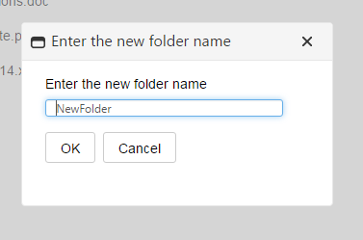

Figure . – New Folder pop-up

### Deleting a Folder

Select the folder you want to delete. Click the “delete folder” button  or right click on the folder and select the “Delete” option from the menu.

## Using the Calendar

To open the calendar, click on the “Calendar” tab  on the navigation bar.

### Changing the Calendar View

The calendar has 4 available views: day, week, month, timeline. The default view is the month view, it will automatically be loaded when you first open the calendar. In order to change the view to the day view click the “Day” button.  To change to the week view click the “Week” button.  You can navigate back to the month view by clicking on the “Month” button. The timeline view shows you a list of appointments for selected day along with the next 2 days. To use the timeline view click on the “Timeline” button.  For your convenience, the currently selected view option is shaded grey.  In the day and week views there is an option for the calendar to show the full 24 hours instead of the default 8AM to 5PM. To enable this click on the “Show 24 hours” button. 

### Navigating the Calendar

In order to move forward by the unit of time currently being displayed click on the forward arrow button.  Likewise to move backwards by the unit of time currently being displayed click the backwards arrow button.  To move the displayed view to today, click on the “Today” button.  To choose a specific date to be displayed click on the downwards arrow.  This will show you a small month view calendar, where you can select the date you wish to display. The current time selection is displayed next to the downward arrow button.

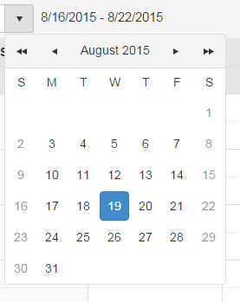

Figure . – Image of small date picker calendar.

### Adding an Appointment

To add an appointment move your mouse over the desired time selection, once your mouse is over a time selection it will become shaded. To select that time spot, double click on the time selection. In the day and week views the default appointment time is 1 hour. In the month and timeline view the default is 1 day. When you double click on a time selection, a small pop-up will appear.

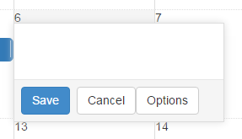

Figure . – Appointment creation popup

If at any time you decide you don’t want to create a new appointment, you can close the pop-up by clicking the “Cancel” button.  In this pop-up, you can enter the subject of the appointment into the text box. Once you have entered a subject, click on the “Save” button  to create the appointment. If you would like to enter more details when creating your appointment, then click on the “Options” button  to take you to another screen that allows you to enter more details.

On the detailed appointment page there is a text box for entering an appointment subject. If you entered a subject before clicking the “Options” button it should be already displayed in the subject. You will still be able to edit the subject even though you entered it into the pop-up. If the appointment is for all day click the “All day” checkbox.  Enter the desired appointment start time into the “Start time” box. Enter you desired appointment end time into the “End time” box. If the appointment is reoccurring, click the “Recurrence” checkbox. When the “Recurrence” checkbox is activated more options for setting the recurrence will appear. Select the options you would like to set for the reoccurring appointment. When all of the options have been selected, click on the “Save” button  to create the appointment. When the appointment has been created the program will take you back to the calendar that will now display your new appointment. If at any point you need to stop creating the appointment, you can click the “Cancel” button  to end the appointment creation.

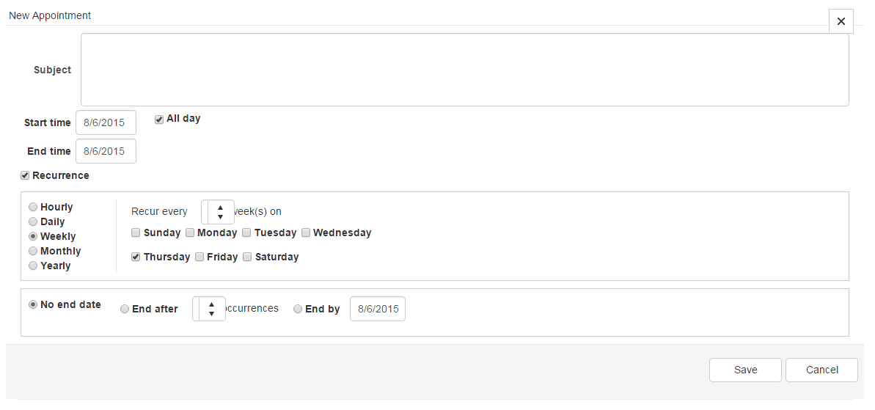

Figure . – Appointment creation details page

### Deleting an Appointment

To delete an appointment place your mouse on the appointment you would like to delete. When your mouse is on the appointment an “X” will now be visible on the right side of the appointment. Click on the “X”. A pop-up will then ask you if you are sure you want to delete the appointment. If you are sure click on the “OK” button.  Alternatively you can stop the delete operation by clicking on the “Cancel” button.  If the appointment is reoccurring, there will be options to delete all of the reoccurring appointments or only the selected appointment.

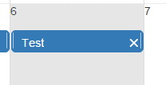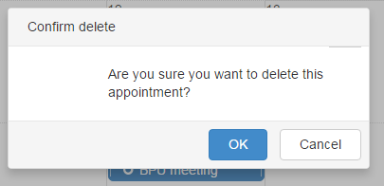

Figure . – Images of delete sequence

## Logging Off

To log off simply click the “Log off” button  in the navigation bar. You can also close the browser. However, we strongly suggest you use the “Log off” button first for security reasons.